Contents

Introduction 2

External Lab 2

Placing a procedure order 3

Checking the result 6

Results 6

Batch Results 6

Unassociated Results 9

Local Lab 10

Creating the lab providers 10

Procedure Configuration 11

# Introduction

Broadly, the labs created will fall into two classification defined below

1. External Lab: These are labs that the facility connects with bi-directionally or uni-directionally but are usually separate entities proving laboratory services for eg Quest, Lab Corp etc.
2. Local Lab: These are labs created by the user which represent labs maintained internal to the facilities defined in the database. Ideally these labs should be physically present in the premise of the facilities defined in the database.

# External Lab

To get to the lab section, to make an external order, we need to first get into an encounter of a particular patient and thereafter go to Modules->Lab (shown below) and it will directly take you to the ‘Procedure Order’ screen, where you can place an external order.

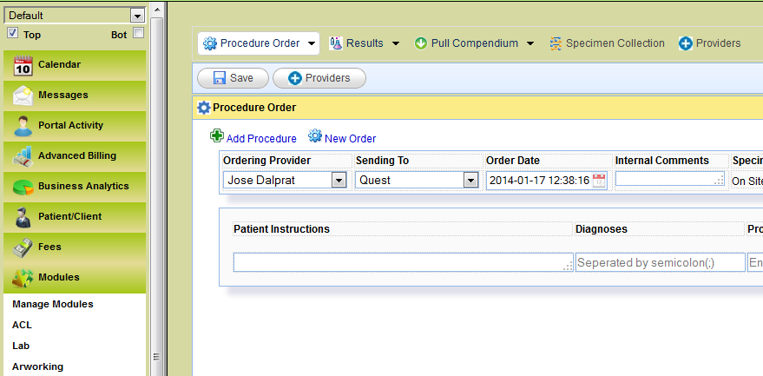

## Placing a procedure order

For placing an external order, we have to give the details as listed below

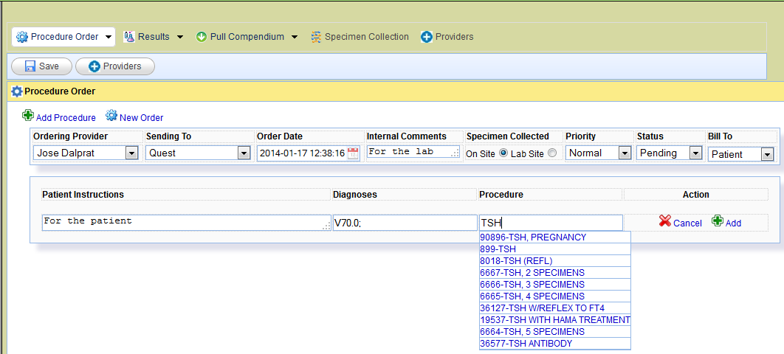

**Ordering Provider**: - This will list down all the names of the providers. We need to choose the ordering provider from the list.

**Sending To**: - This will list all the external labs to which the orders can be send to.

**Order Date**: - It is the time stamp when the order is being placed.

**Internal Comments**: - These are comments that are send to the lab. The user can free text into this area.

**Specimen collected**: - In this we mention whether the specimen for the testing is collected in the facility itself or in the site of the external lab.

**Priority**: - This is to set the priority.

**Status**: - Gives the status of the labs.

**Bill To**: - This gives the details as to who should be billed. There are 3 options for the same 1) Patient: - When the bill is borne by the patient. 2) Third party: - When the bill is borne by the insurance. 3) Facility: - When the bill is borne by the facility itself.

**Patient Instructions**: - This is the data that needs to be free texted and it will be given to the patient along with the result.

**Diagnosis**: - Diagnosis code for a test is entered in here. On typing a few letters/number’s to begin with, the diagnosis starting with those letter’s/number’s will get automatically suggested.

**Procedure**: - Here we list the code for the lab procedure. On typing a few letters/number’s to begin with, the procedure’s starting with those letters/number’s will get automatically suggested.

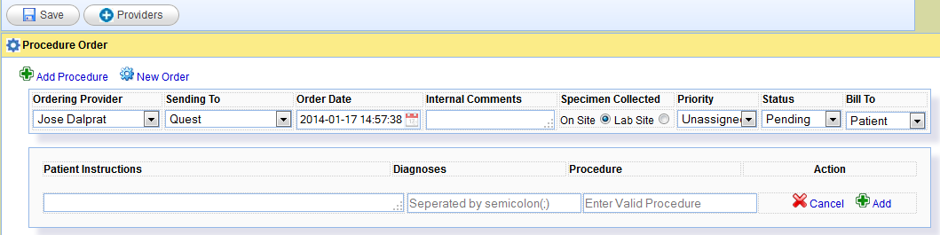

On clicking on either of the ‘Add’ button shown above, we can add a second test procedure as shown below. We can add multiple tests by clicking on the ‘Add’ button.

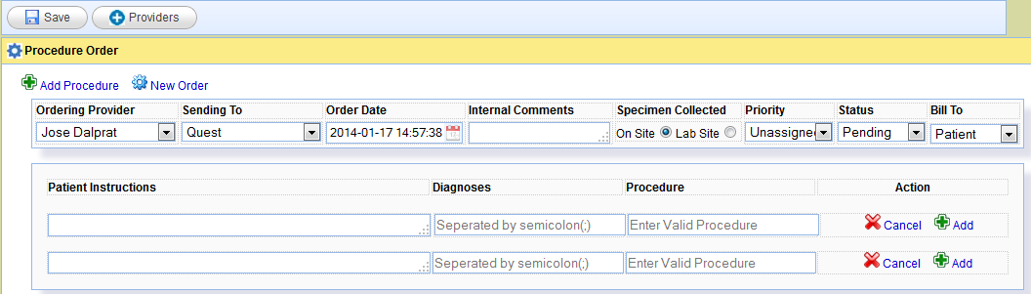

If we wish to add a new order all together, we need to go and click on the ‘New Order’ marked in the figure above. On clicking on the new order, we will have a window open to place a separate set of orders.

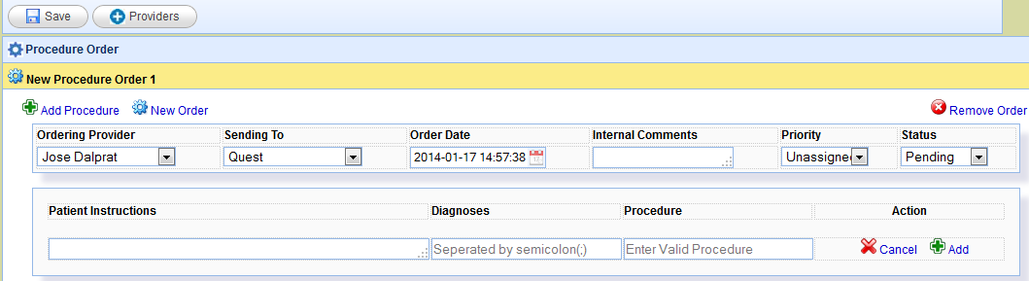

We can also remove the order by clicking on the ‘Remove Order’.

After we create an order, to send the order to the lab, we need to click on the save button (shown below).

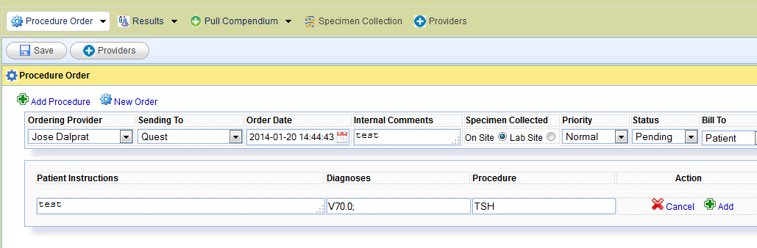

On clicking on the ‘Save’ button, the screen is automatically changed to the ‘Results’ screen where we can see the status of the order.

## Checking the result

### Results

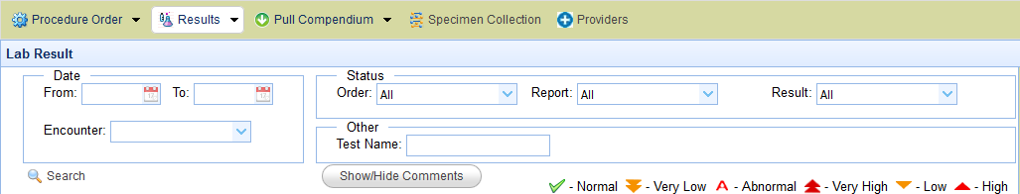

In the result screen, we will only see the result for this particular patient that we had selected when we created this test.

The result screen will show the results of just a single patient at a time.

### Batch Results

There are other options like batch results and unassociated results that can be selected.

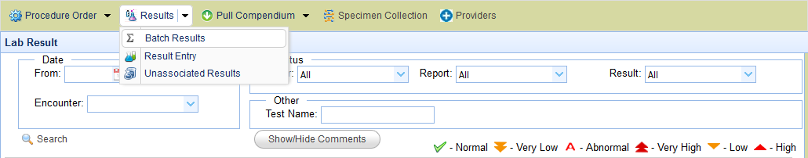

On selecting the ‘Batch Results’ we get all the results of all the patients and their respective status.

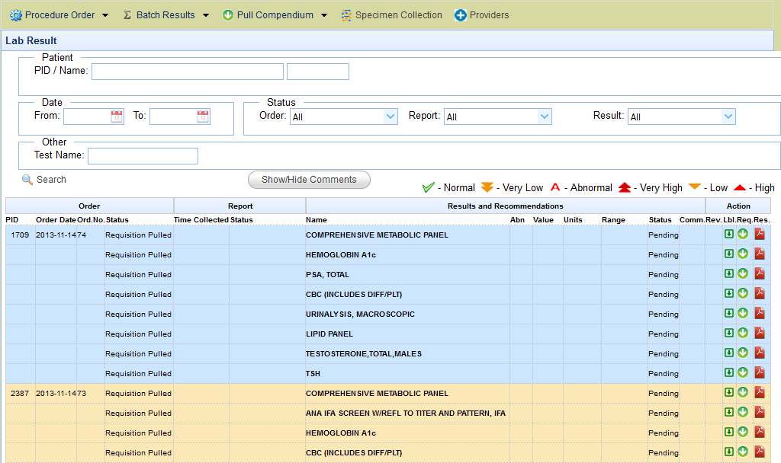

In the top section we have the options to filter out the results on the basis of various different criterions (The ‘Results’ option is also similar, except that it is associated with 1 particular patient. The ‘Batch Result’ is associated with all the patient’s).

Explanation of the result screen

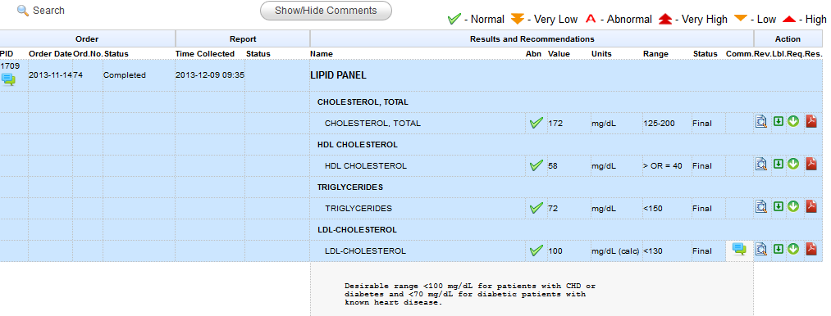

The result screen can be broken into various sections

**Order**: - Under the order there are details of the order that is being placed

-PID: - The patient ID of the patient on which the lab test is undertaken

-Order Date: - The date on which the order is done

-Order No.: - The unique date on which the order is made

-Status: - This column gives the status of the order (Whether pending, completed etc.)

**Results and Recommendations**: - This sectiondeals with the results and associated recommendations.

-Name: - Gives the name of the test

-Abn: - Gives the details as to whether the test is normal, very low, abnormal etc.

-Value: - Gives the actual value that associated with the test for the particular patient.

-Units: - The unit in which the value is given.

-Range: - The normal range that is acceptable for this test.

-Status: - The status of the test (whether pending. Final etc.)

-Comm.: - This is the comments section.

**Action**: - The section to the extreme right is the action section. It has the following parts.

-Rev: - This section enables the user to review the tests one after the other. It also allows the user to add any review comments and sign.

-Lbl: - This give the label which can be put on the sample which is being send for testing.

-Req: - This will give the requisition that is generated and send to the labs.

-Res: - This will give the lab result in a PDF format.

### Unassociated Results

If there is any error in the result that comes in and the system is unable to associate a result that comes in electronically from the lab, then the result will go and lie in a field called ‘unassociated results’ shown below

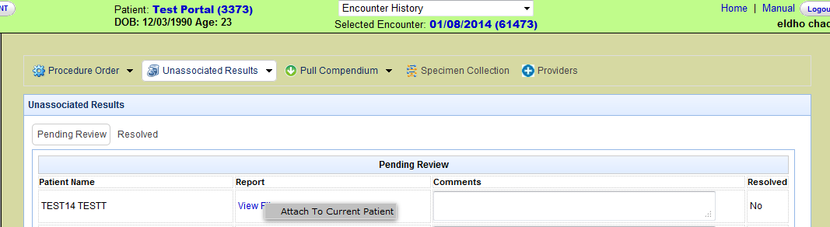

The user can associate a particular result to the current patient that is chosen on the screen by right clicking on a view file option and attaching the result to the current patient as shown above.

# Local Lab

## Creating the lab providers

We can create a local lab for the user by adding it as an option in the ‘Provider’ tab which is shown below.

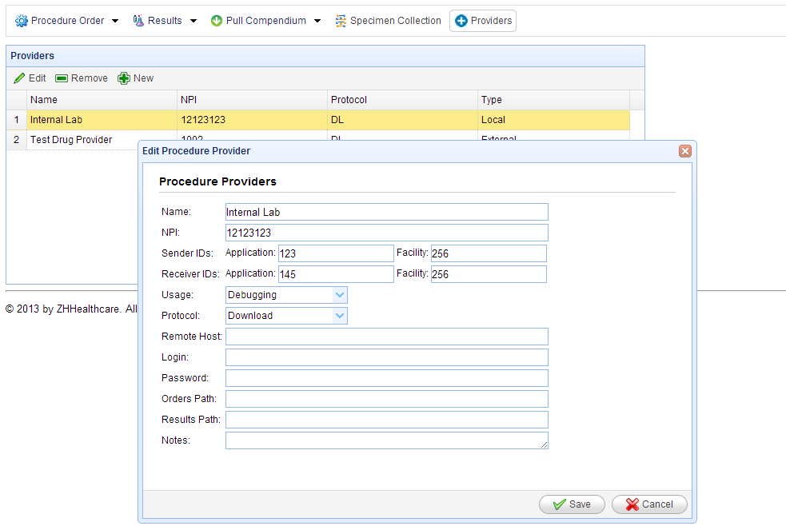

If we click on the ‘New’ Option that is marked above, we get the option to add a local lab by filling in the details that is shown above.

Name: - The name that we want to give to the local lab that we are setting up.

For internal lab the remaining fields are not mandatory. Only we need to put in the name. If we need to install an external lab we have to put in the other fields too. These settings will be setup for you by the administrators.

Once we have add the details, we will get the internal lab listed as shown below.

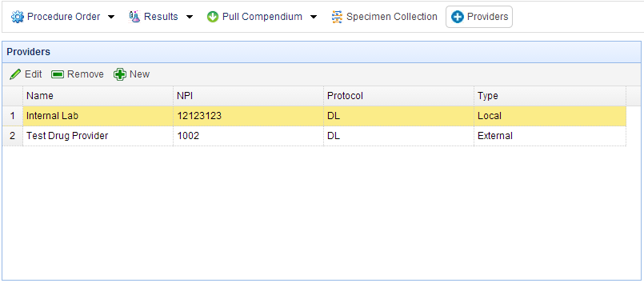

## Procedure Configuration

Next we will take a look at the procedure configuration

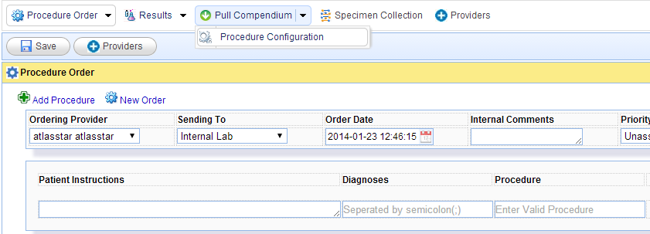

On clicking on the procedure configuration we will move to the